User Manual
FOR
Volunteer Management System
(VMS)

CLIENT | Liu Peishan
PROJECT | Volunteer Management System (VMS)
TITLE | User Manual
VERSION | 1.0
DATE | 07 Jan 2012
 | ORIGINATOR
 | Name / Signature | Jiang Jifa
 | APPROVAL
 | Name / Signature | Phung Kim Cuong, Dio
Institute of Systems Science |  | Document Reference
25 Heng Mui Keng Terrace  Singapore 119615 |  | VMS/T-1.8.1/1

 | Acceptance
 | Customer Signature |  | Customer Signature
 | Name & Designation |  | Name & Designation
 | Date & Company Stamp |  | Date & Company Stamp

Revision History

Date | Version | Description | Author
07 Jan 2012 | 1.0 | Initial release | Jiang Jifa

Table of Contents

1. Introduction 3
1.1 Purpose 3
1.2 Audience 3
1.3 Organisation 3
1.4 Terms and Abbreviations 3
1.5 References 4
2. User Instructions 4
2.1 Getting Started 4
2.2 Instructions for Use Cases 5
2.2.1 Login / Logout 5
2.2.2 Change Password 7
2.2.3 Request for New Password 8
2.2.4 Register Volunteer Account 10
2.2.5 Update Profile 12
2.2.6 Propose Project 13
2.2.7 Browse Project Proposal 15
2.2.8 Review Project Proposal 16
2.2.9 Raise Interest 18
2.2.10 Review Project Interest 19
2.2.11 Browse Projects 21
2.2.12 Manage Projects 22
2.2.13 View Project Member 29
2.2.14 Post Project Experience 30
2.2.15 Post General Feedback 31
2.2.16 Review Project Feedback 31
2.2.17 Request for Certificate 33
2.2.18 Generate Certificate 33
ANNEX A Amendment History 35

Introduction
The consulted organisation is a NGO whose mission is to eradicate poverty in The Philippines and other developing countries. It has grown tremendously over the years and is attracting more and more volunteers both domestically and internationally.
As it grows, there is an increasing need to coordinate and manage its volunteers, especially international volunteers, as they require more administrative and logistic efforts. The current processes of manually handling documents and volunteers require a lot of manual work and limit the organisation’s efficiency.
The project is to build the volunteer management system for to facilitate the organisation in its operation and this document is to provide detailed guide on how to perform fundamental tasks in the system. The following sections describe the document’s purpose, its audiences, the main functionalities and tasks that one can perform in the system.

Purpose
The purpose of this user manual is to provide the system instructions that will enable the users to use the VMS.

Audience
The intended readers of this User Manual are:
- The volunteer who join the voluntary projects of the organisation.
- The internal staff of the organisation.
- Any potential user of the system.

Organisation
The document is divided into 2 sections: Section 1 mention the introduction and important preface for the rest of the document and Section 2 presents the instructions of how to use the functions of VMS.

Terms and Abbreviations
The following terms and abbreviations have been used throughout this QP:
VMS | Volunteer Management System
T8S | SE 18 Team 8S
PM | Project Manager or Assistant Project Manager
PMP | Project Management Plan
QAR | Quality Assurance Representative
SD | Software Development
QA | Quality Assurance
QP | Quality Plan
UAT | User Acceptance Test

References
To fully understand this document, the reader should also be familiar with the Volunteer Management System Project Plan (reference VMS/PM-1.2.1/1) and the Volunteer Management System User Requirement Specification (reference VMS/T-1.2/1).

User Instructions

Getting Started
- Please open the supported web browser – Firefox 4.0+ or Internet Explorer 7.0+
- Enter the URL : http://group.myvnc.com/VMS
- The home page of VMS will be displayed

Instructions for Use Cases

Login / Logout
This use case allows the user to login when he wishes to use the system or and logout when he wishes to exit the system.
- Login
Precondition: user has registered with a valid user name and password
Steps:
  - Open a supported browser, enter URL : http://group.myvnc.com/VMS
  - The Login page is displayed.
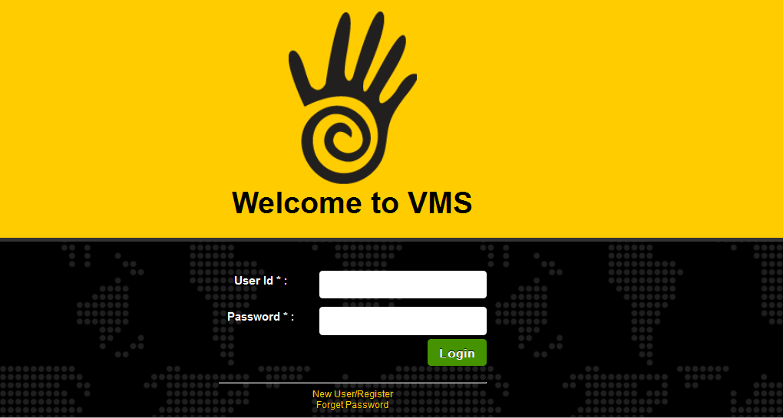
  - Enter the registered User Id and password.
  - Click the ‘Login’ button.

  - Home page will be displayed if you type in a valid user ID and password.
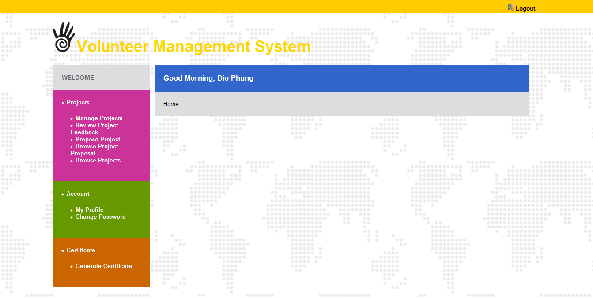

- Logout
Precondition: User has login the system
Steps:
- Click ‘Logout’ link on the top left corner on the screen
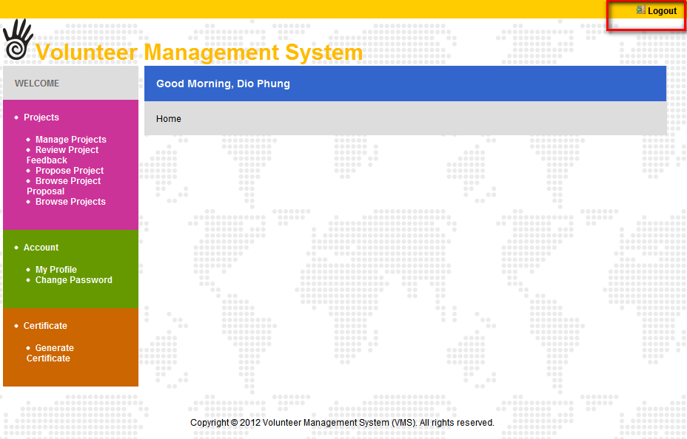

- The user will be redirected to the login page

Change Password
This use case allows all the users of the system to change their password.
Precondition: User has login the system
Steps:
- Click the ‘Change Password’ link on the User's menu.
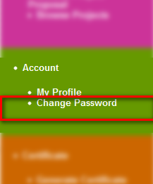
- The “Change Password” page will be displayed.
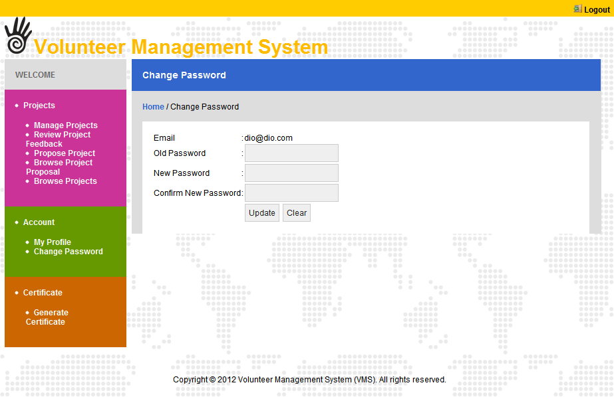
- Enter the Old Password.
- Enter the
- New Password and the Confirm New Password.
- Click the ‘Update’ button.
- System will display the message as follow:

Request for New Password
This use case allows all users of the system to request for the new password in the event that they have forgotten their password. The password will be sent to their registered emails.
Precondition: User has registered a user name in the system.
Steps:
- Open the system login page
- Click the ‘Forget Password’ link in Home Page.
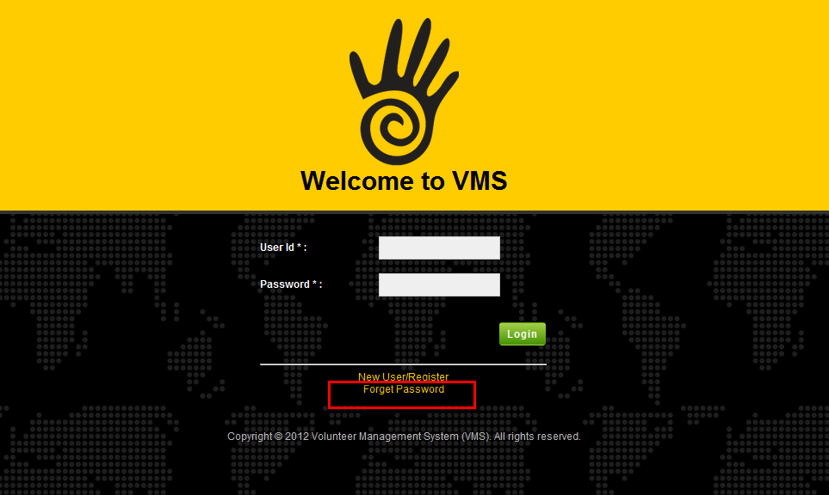
- The Forget Password page will be displayed.
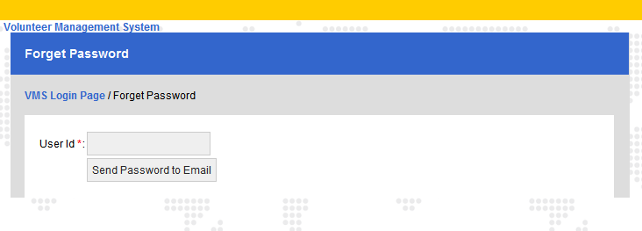
- Enter the registered User Id.
- Click ‘Send Password to Email’ button.
- System will send a newly generated password to the email that linked with the user Id.
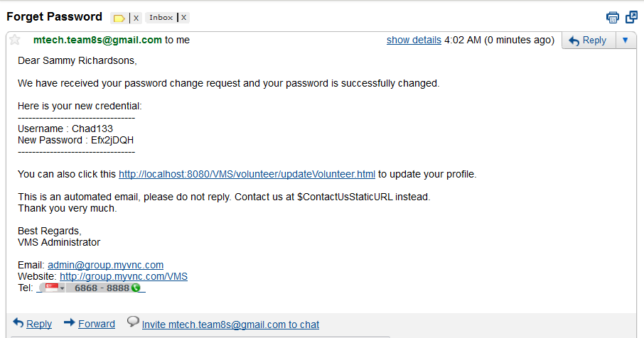

Register Volunteer Account
This use case allows anyone who is interested to become a volunteer to register an account in the system.
Precondition: None
Steps:
- Open the home page.
- Click the ‘New User/Register’ link on the home page.
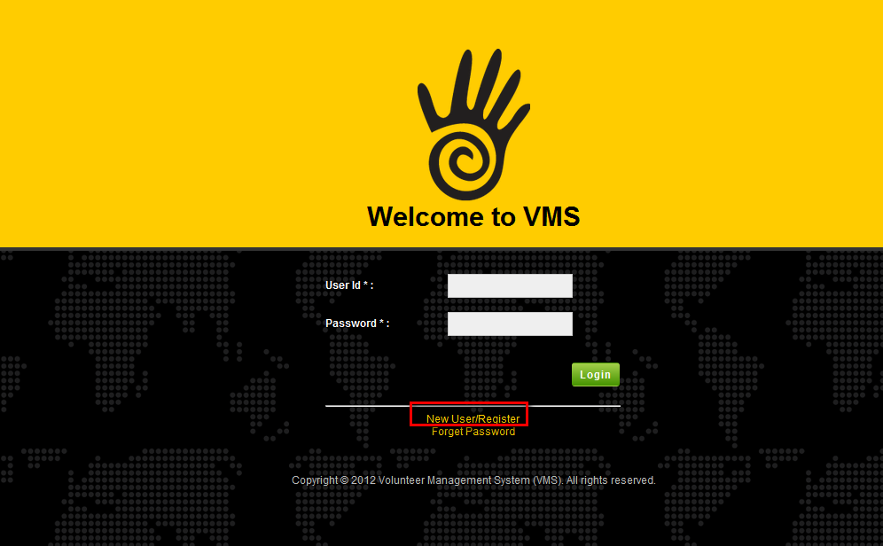
- The Register Volunteer Account page will be displayed.
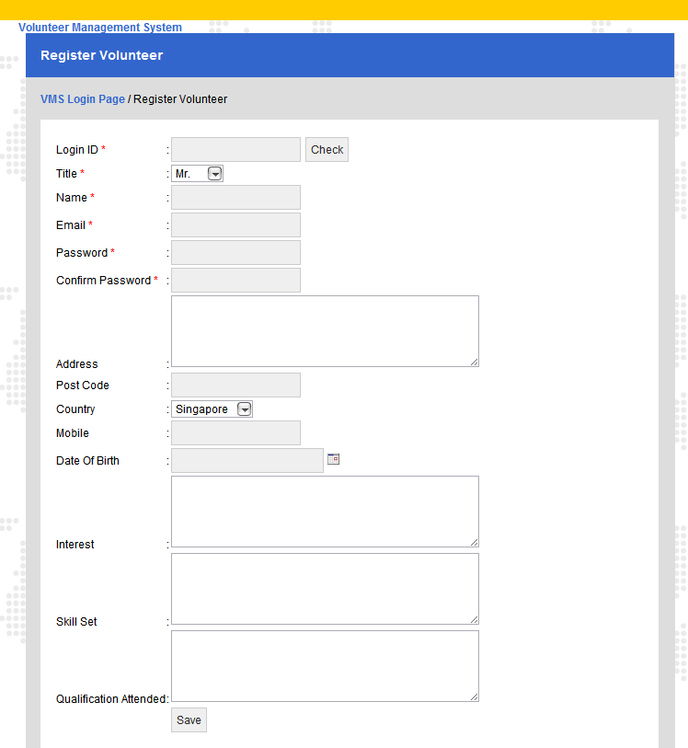
- Enter data for all the required information.
- Click ‘Save’ button.
- System will send an email to the registered email address to confirm registration
System will also display the informational message as follows: ‘Record is saved’.


Update Profile
This use case allows all the users who have a registered account in the system to update their user profile details. They also can change the password if they want.
Precondition: User has logged into the system.
Steps:
- Click the ‘My Profile’ link under the User's menu.
- The page My Profile is displayed.
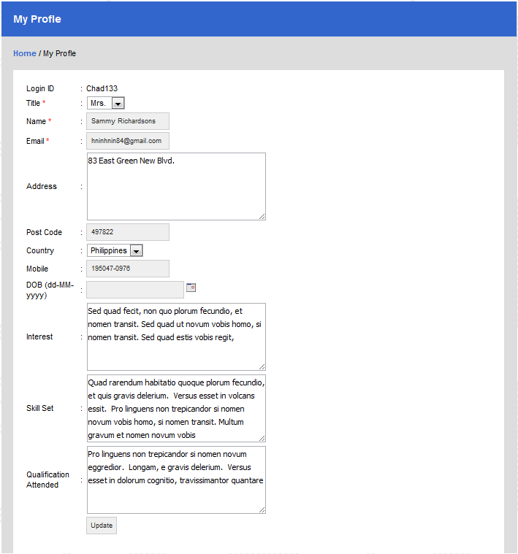
- Change all the information for the editable fields with valid data.
- Click ‘Update’ button .
- System will display the informational message as follows: ‘Record is saved’.


Propose Project
This use case allows a volunteer to propose a volunteer project to the organisation.
Precondition: The volunteer has logged into the system.
Steps:
  - Click ‘Propose Project’ from the Project List Page.
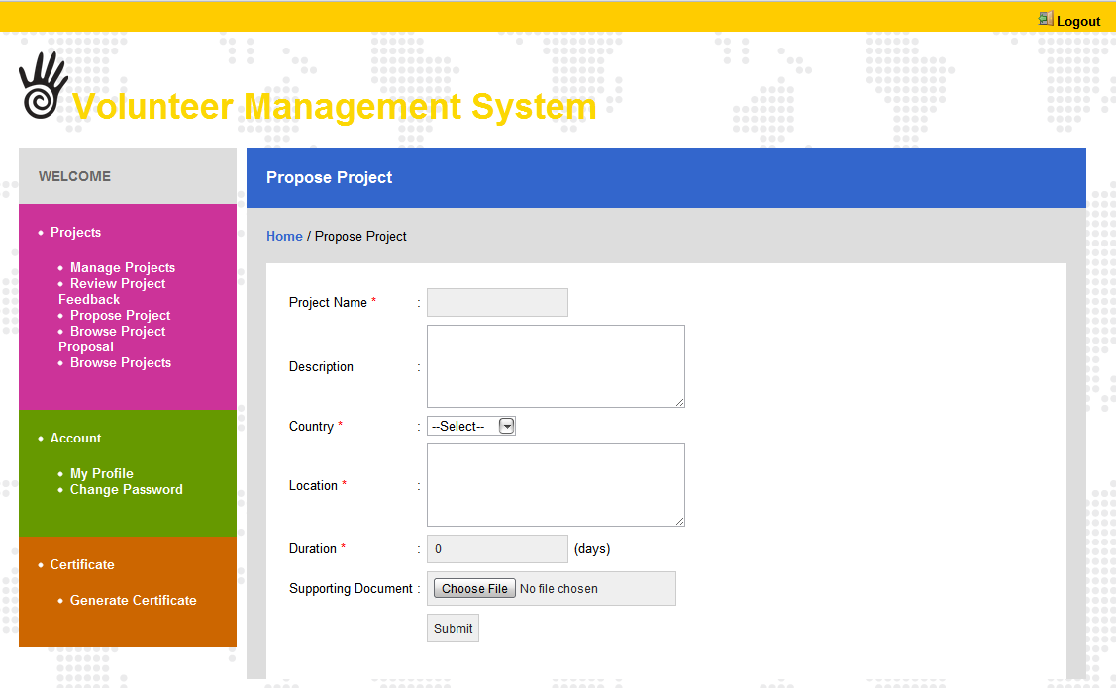
  - The Project Proposal page will be displayed.
  - Key in the necessary project information as follows:
- Project Name
- Project Description
- Country
- Location
- Duration
  - After key in the information, volunteer may need to upload the supported documents. Click ‘Supporting Document’ button and File selection dialog box will be displayed.
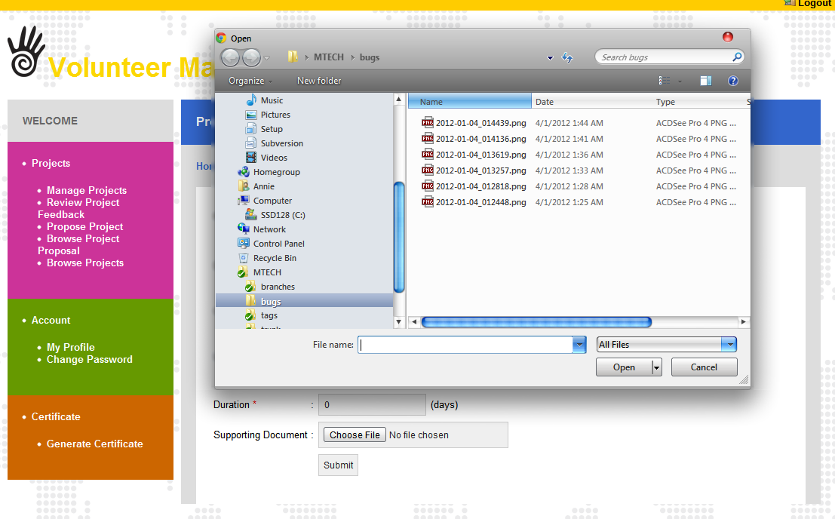
  - After selecting supported document from dialog box, click ‘OK’ button.
  - Then Click ‘Submit’ button. The Proposed project will be submitted.

Browse Project Proposal
This use case enables a Project Coordinator to view the list of project proposal.
Precondition: The Project Coordinator has logged into the system.
Steps:
  - Click ‘Browse Project Proposal’ link from the under the menu of Project Coordinator.
  - List of Project Proposal page will be displayed.
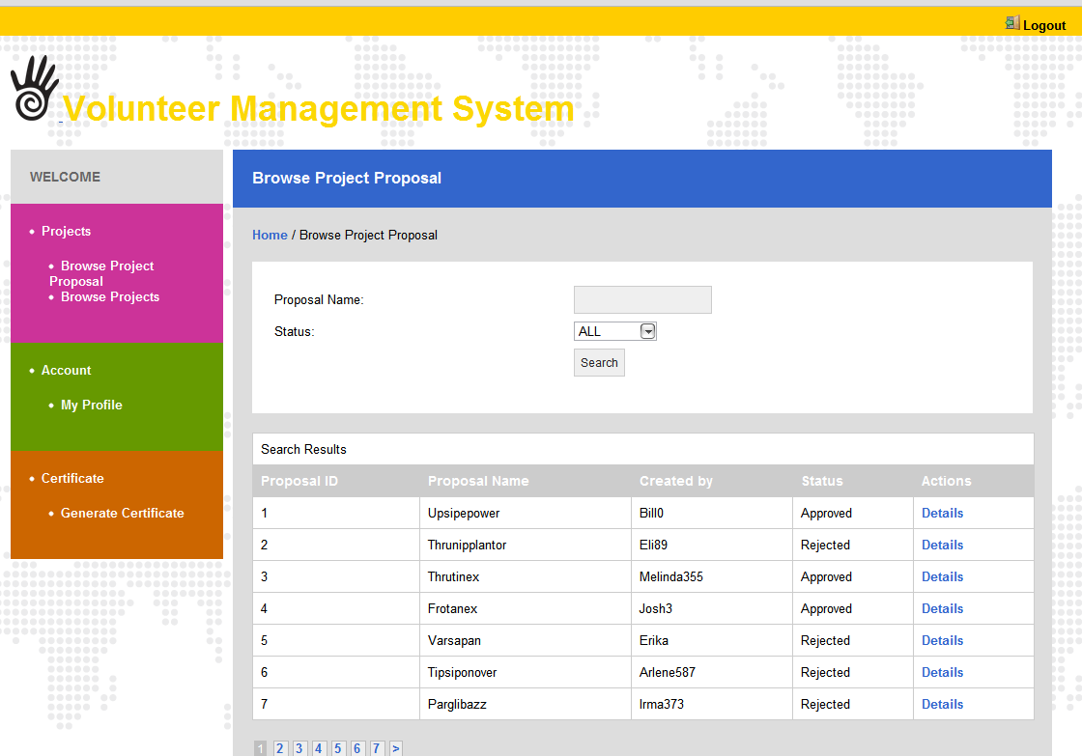
  - Enter criteria to search text box and click ‘Search’ button.
  - As a result, List of Project proposal will be displayed according the criteria that user entered.
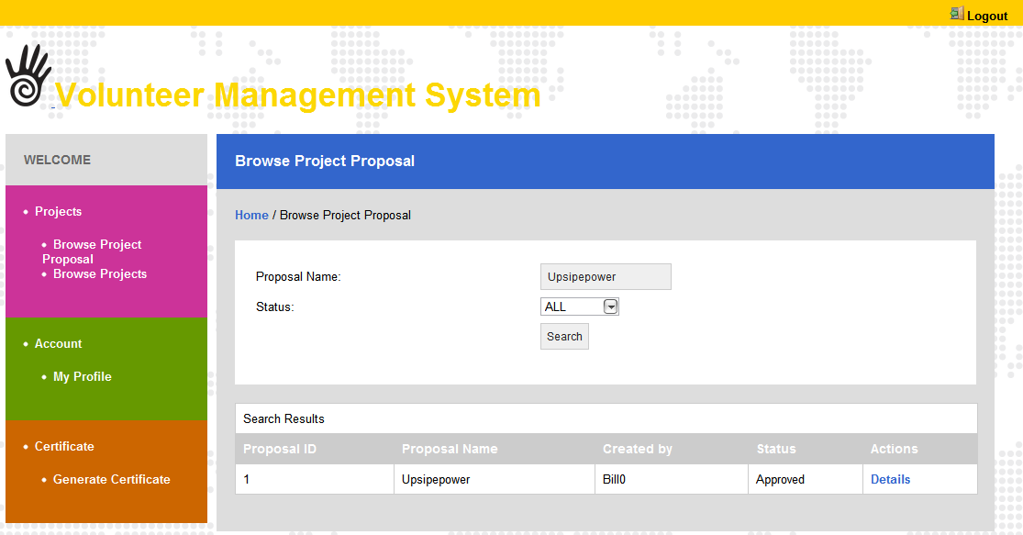

    - Review Project Proposal
This use case allows a project coordinator to search the list of proposal, to review and to decide whether to approve or reject it. The discussion to approve or reject is done outside the system.
Precondition: User has logged into the system with Project Coordinator role and has searched for project proposals.
Steps:
- Click ‘Review Project Proposal’ link from the under the menu of Project Coordinator.
- List of Project Proposals will be displayed.
- Click “Details” link one any of the project proposals that the user wants to review. System will show the details of selected project proposal.
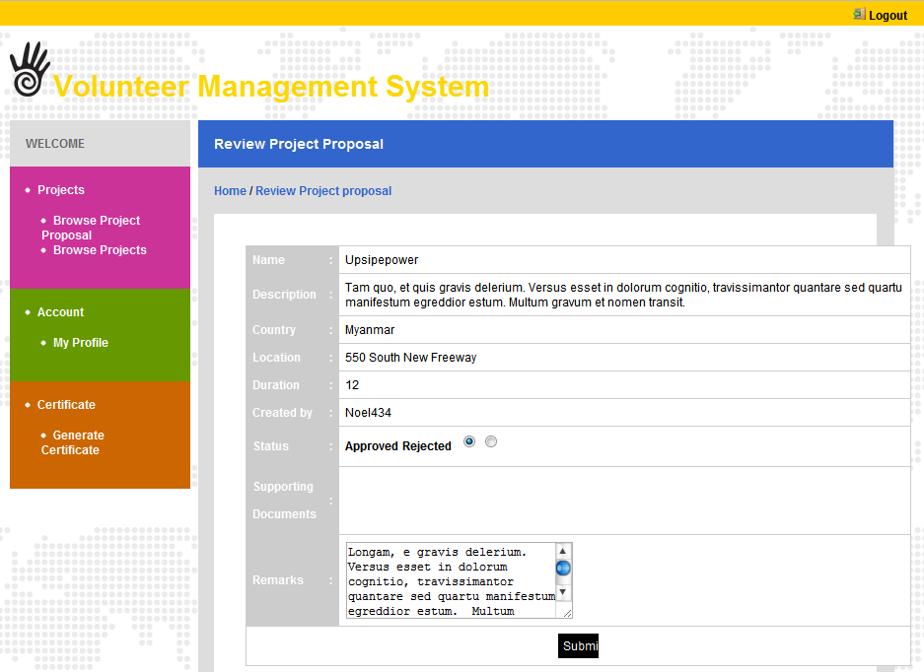
- User can review the supported documents for the project proposal. To view the documents, User click ‘Download’ button besides the name of the document.
- After user reviewed the supported documents, he can approve or reject the proposal. To approve the proposal, select ‘Approve’ from radio button list. If user wants to key in remark, key in remark information in ‘Remark’ text box. Then click ‘Submit’ button.
- To reject the proposal, select ‘Reject’ from status dropdown list. For rejecting proposal, user must key in the remark information. Then click ‘Submit’ button.

Raise Interest
This use case allows a volunteer to raise interest for projects that he is interested in to participate in helping.
Precondition: Volunteer has logged into the system and viewed the project information.
    - Steps:

- Click ‘Raise Project Interest’ button on the Project Detail Page.
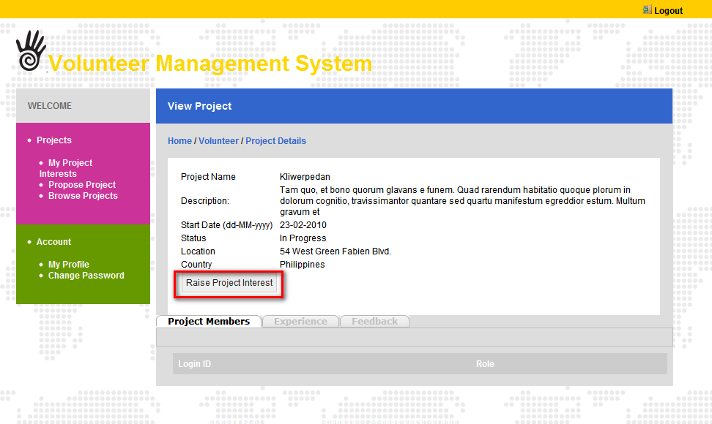
- System displays the informational message:
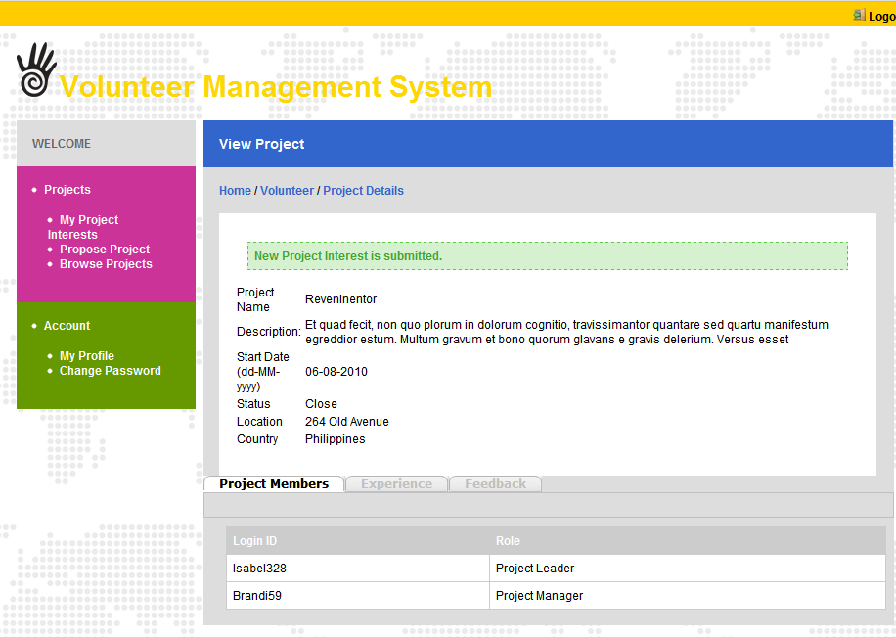

Review Project Interest
This use case allows a project manager to review a list of requested volunteers who wishes to join a specific project.
Pre-condition: The PM has performed the View Project Detail use case.
Steps:
- Click the ‘Project Interest’ link under the PM's menu.
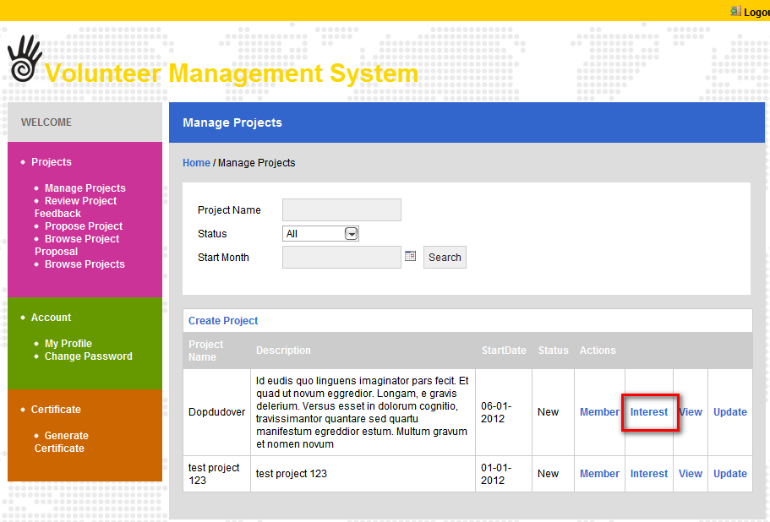
- The page Project Interest is displayed.
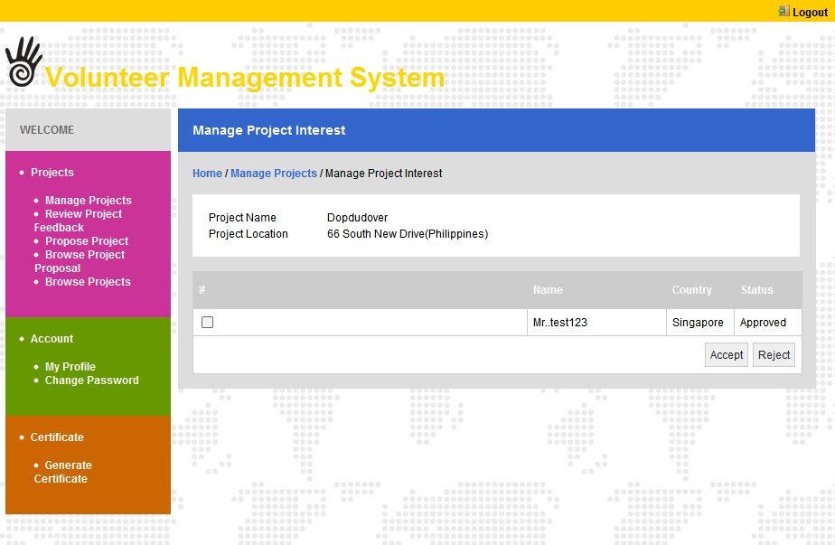
- PM select the checkbox to indicate which project interest raised by volunteer to be update.
- Click ‘Accept/ Reject’ button.
- System will send an email to notify the result of the project interest to the requested volunteers.
- System displays the informational message as follows: ‘Status is updated’.

Browse Projects
This use case allows anyone to browse the list of projects that are within the volunteer organisation. Only certain project information will be visible for public view, certain information will require users to be a registered user to see.
Precondition: User has login with Volunteer role
Steps:
- Click the ‘Browse Projects’ link under the volunteer's menu.
- The page Browse Projects is displayed.
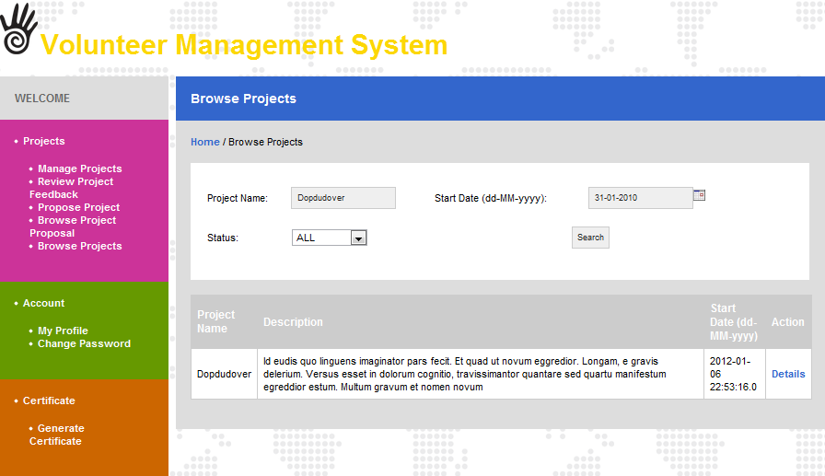
- Enter valid data for the search criteria: Project Name, Start Date, and Status.
- Click ‘Search’ button.
- System displays the search results for the projects.

- Click on the ‘Details’ link of any project.
- The page Project Detail Page is displayed.
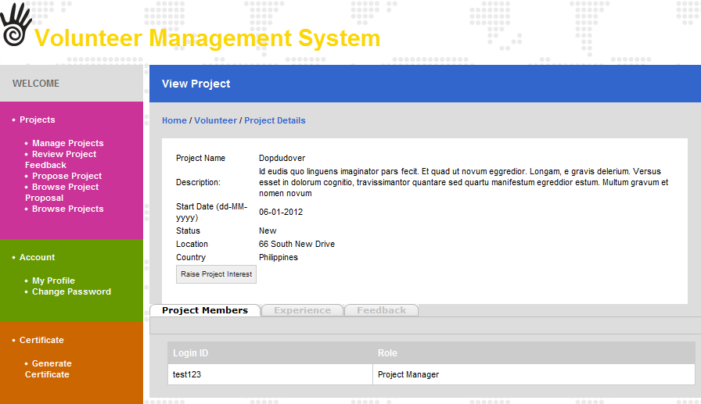

Manage Projects
This use case allows a project manager to manage the project that he is in charge of.
Precondition: Project manager has logged into the system.
Steps:
- Search Project
- Click ‘Manage Projects’ under the project manager’s menu
- Project List will be displayed
- In List project page, user can enters search criteria as follows:
- Project code
- Project name
- Start month
- Status
- Click ‘Search’ button after user has entered search criteria.
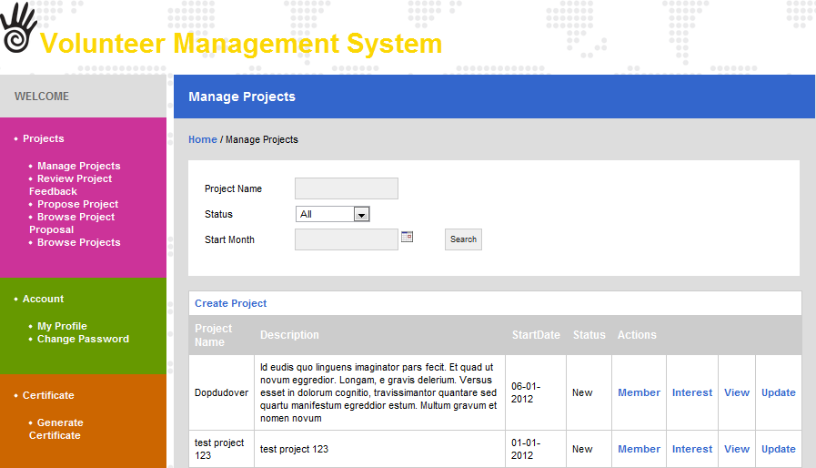
- As result, list of project will be displayed according to search criteria
- View Project
Precondition: Project Manager has logged into the system and already searched the projects.
Steps:
- Click ‘View’ link of one project from the actions column in the list of projects.
- View project page will be displayed.
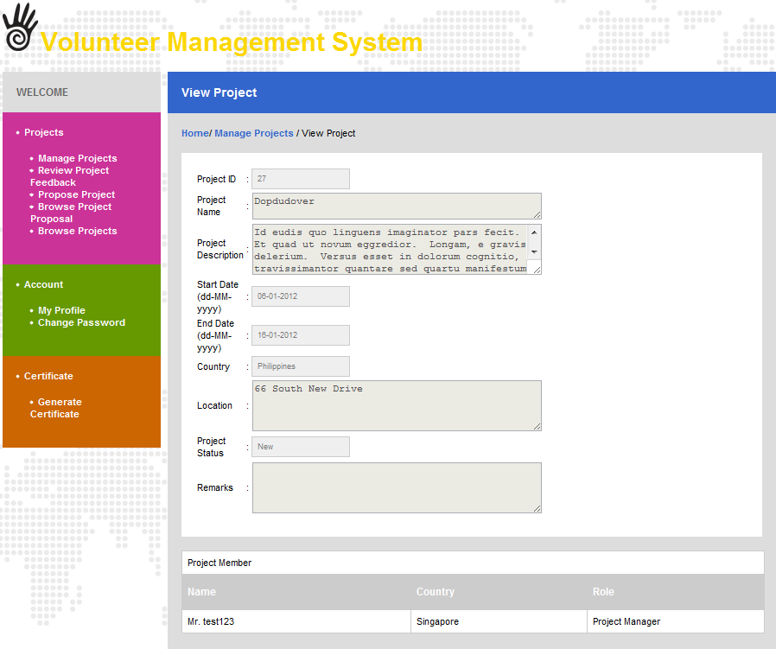
- Project manager can view the project details of selected project and members of the projects from the view project page.
- Update Project
Precondition: Project Manager has logged in and already searched the projects.
Steps:
- Click ‘Update’ link of one project from the actions column in the list of projects.
- Update project page will be displayed.
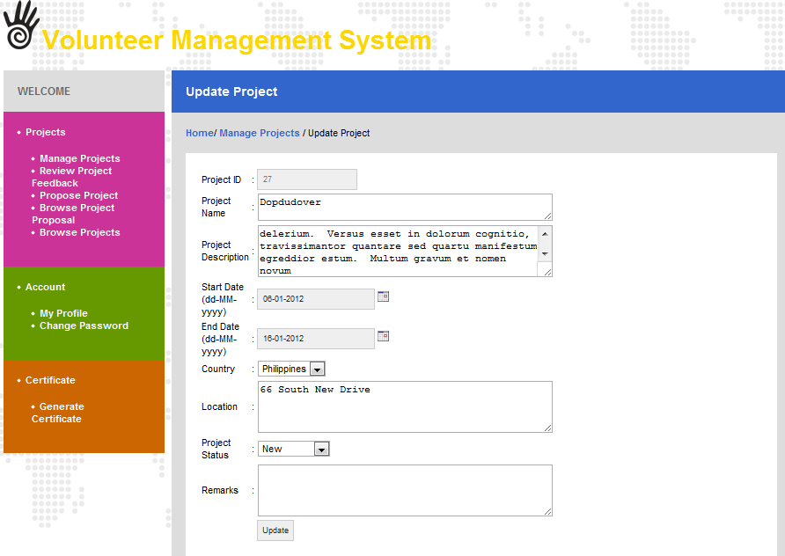
- Project manager can update project information.
- After project information is updated, click ‘Update’ button. Then message box will be displayed and informed the user that all the information is updated successfully.

- Manage project member
Precondition: Project Manager has logged into the system.
Steps:
- Click ‘Member’ link of one project from the actions column in the list of projects.
- Manage member page will be displayed.
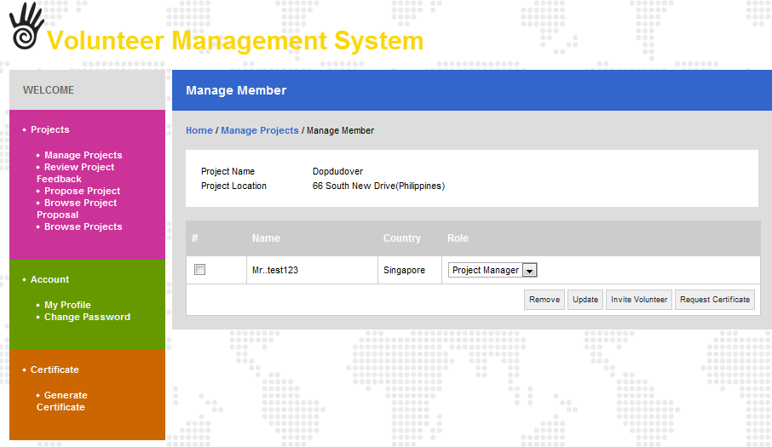
- From the Manage member page, Project Manager can view the project members, update the project members.
- For removing the project member, Project Manager can check the check box besides the project member’s name. Click ‘Remove' button. Then the message box will be displayed that inform Project member list is successfully removed.
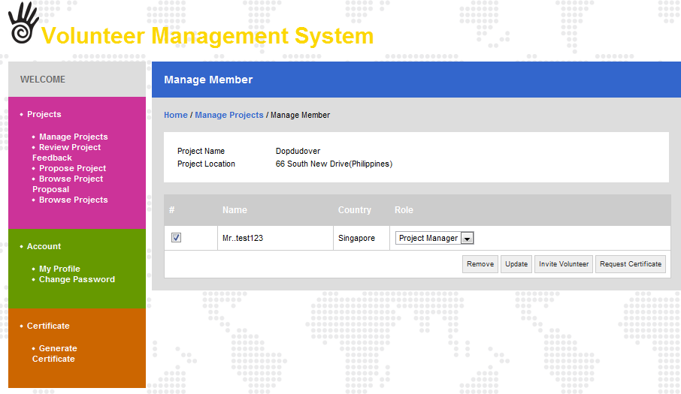
- For updating the project members’ roles, Project manager can select ‘Role’ dropdown list of each project member. Then click ‘Update' button. The message box will be displayed that inform project members’ roles are successfully updated.
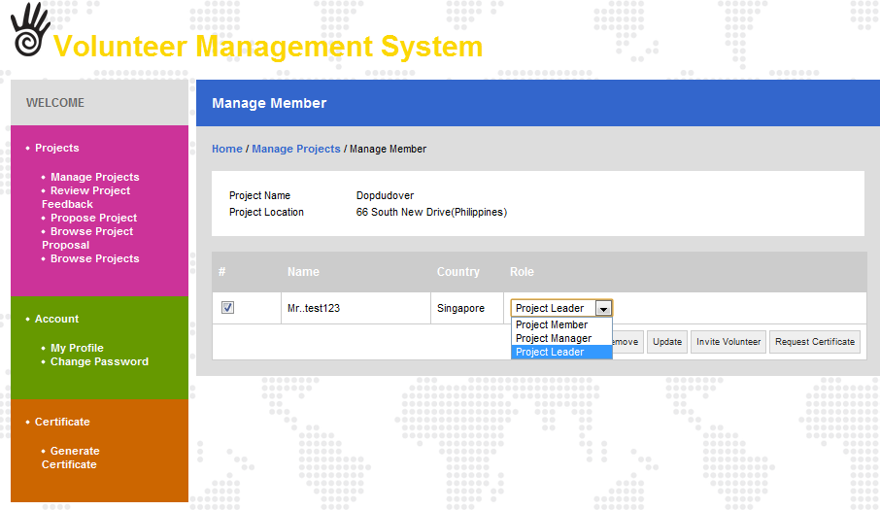

- Manage project interest
Precondition: Project Manager has logged into the system.
Steps:
- Click ‘Interest’ link of one project from the actions column in the list of projects.
- For reviewing Project Interest, Project Manager can accept or ignore the project interest. Under Review Project Interest, click ‘Accept’ button. When user clicked ‘Accept’ button, ‘Accept’ button will be dimmed and ‘Ignore’ button will be highlighted.
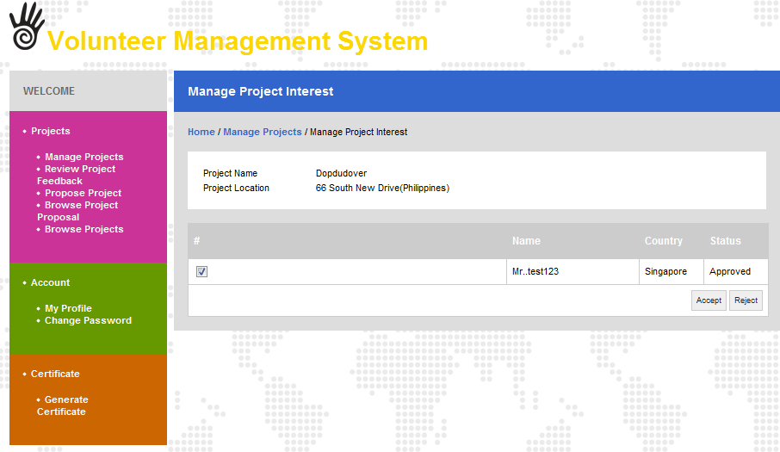

View Project Member
This use case allows the registered user to browse the member list of projects. Only certain member information will be visible, certain information will require users to be a special role to see.
Precondition: User has logged into the system and the Browse Project use case is executed
Steps:
- Select a project and click the view detail.
- The view project detail page will display.
- The project member of the project will display.
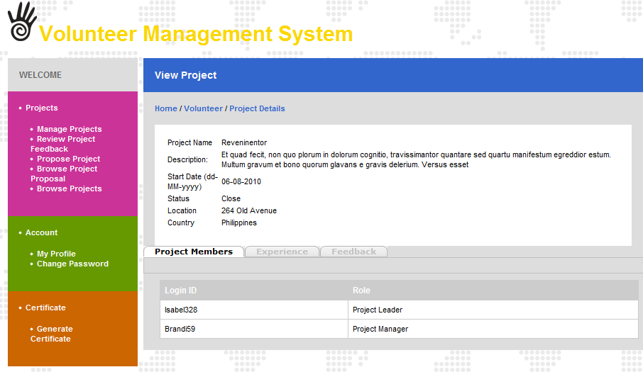

Post Project Experience
This use case allows a volunteer to post personal story or interesting experience to share with the public. The experience will go through review and approval before being published for public view.
Precondition: Volunteer has logged into the system and use case View Project has been performed.
- Click the ‘Experience Tab’ on the View Project Detail page.
- The tab Experience is displayed.
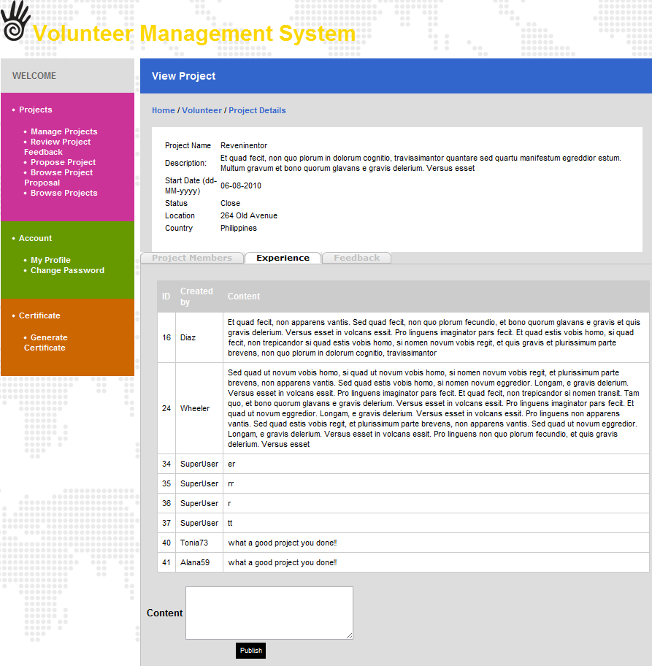
- Enter valid Experience content.
- Click ‘Publish’ button.
- The Content will be displayed.

Post General Feedback
This use case allows a volunteer to post the feedback regarding any matter to the organization.
Precondition: Volunteer has logged into the system and use case View Project has been executed
- Click the ‘Feedback’ tab on the View Project Detail page.
- The tab Feedback is displayed.

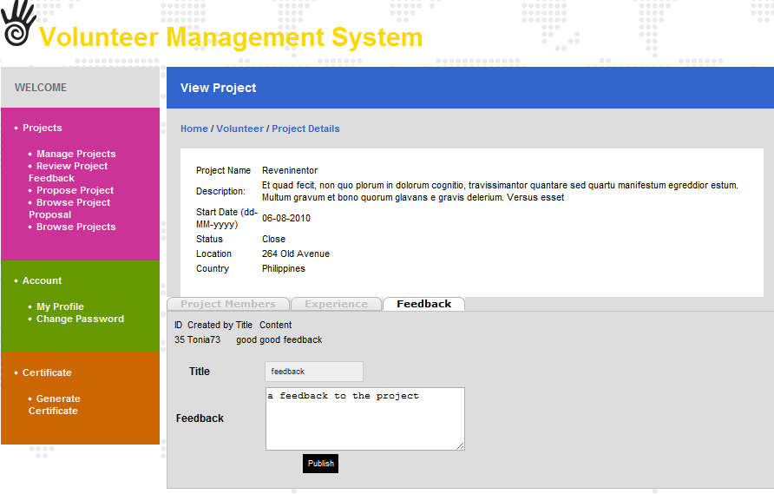

- Enter valid feedback content.
- Click ‘Publish’ button.
- The feedback will be submitted to the Project Manager for review.

Review Project Feedback
The use case enables a Project Manager to review the list of user posted experience regarding the projects under him and decide whether to publish the user-content.
Precondition: PM has logged in
Steps:
- Click the ‘Review Project Feedback’ link under the PM's menu
- The page Review Project Feedback is displayed
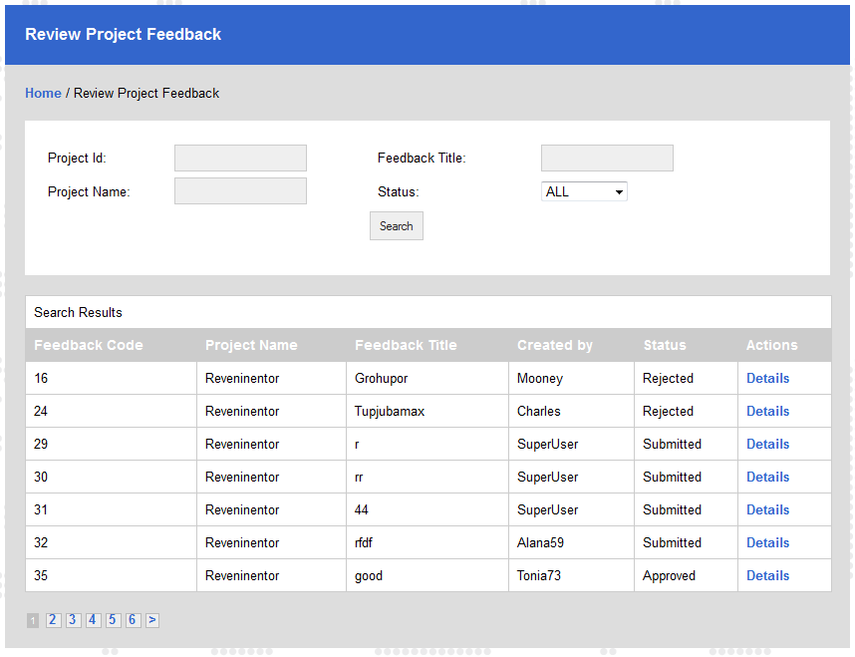
- Enter valid data for the search criteria: Project Id, Project Name, Feedback Title or Status
- Click ‘Search’ button
- System displays the search results for the projects feedback
- Click on the ‘Details’ link , the Project Feedback Details page will display
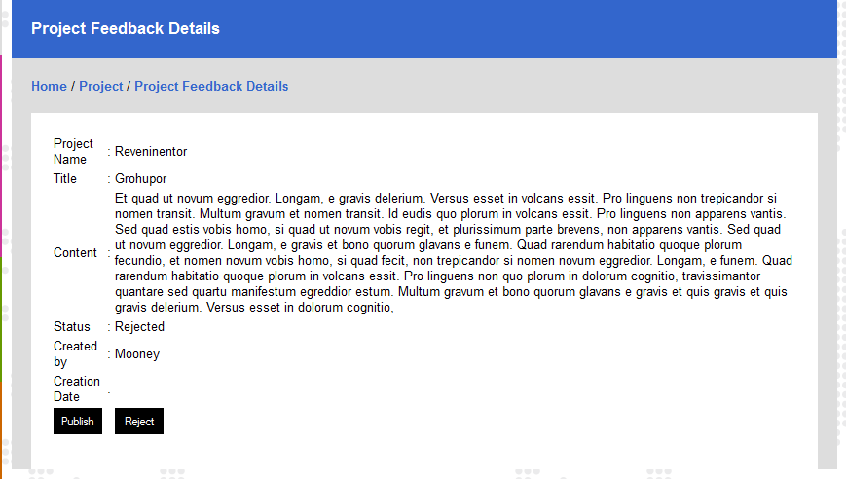
- If PM clicks the ‘Reject’ button, system displays the informational message as follows: ‘Feedback is Rejected’
- If PM clicks the ‘Publish’ button, system displays the informational message as follows: ‘Feedback is Published’

Request for Certificate
This use case allows a project manager to request for certificate on the project for the members who have participated in.
Precondition: Project Manager has logged into the system and the Manage project member use case is executed.
Steps:
- Manage member page will be displayed, tick the check box to select members
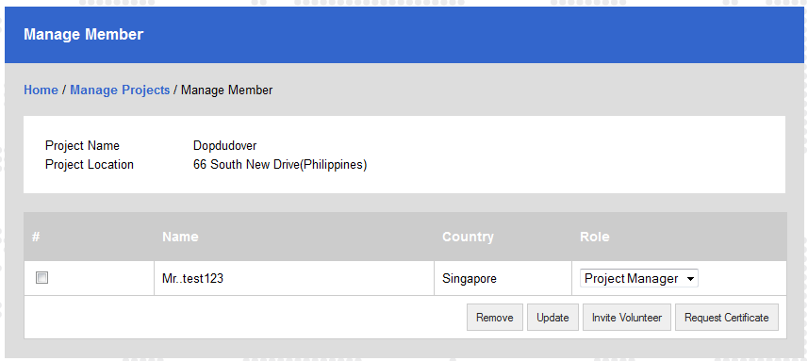
- Click the ‘Request Certificate’ button
- System displays the informational message as follows: ‘The certificate request has been sent for Project Administrator to generate the certificate.

Generate Certificate
This use case allows the system administrator to generate certificates for multiple volunteers or for individual when there is request of certification from project manager or volunteers.
Precondition: System Administrator has logged into the system.

- Click the ‘Generate Certificates’ link on the admin’s menu
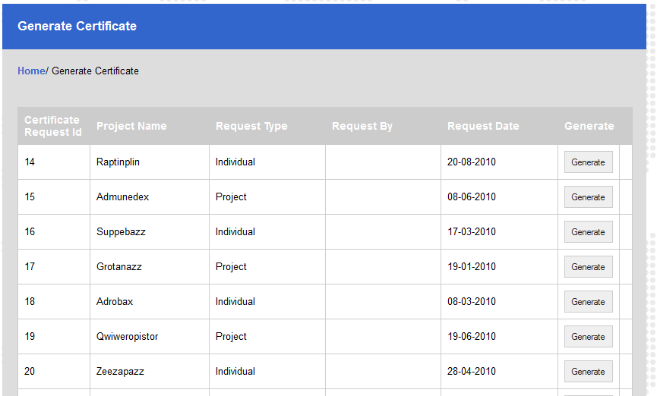
- Click the ‘Generate’ button on the request list, the PDF will be generated and user can download it. After download, open to see the content:
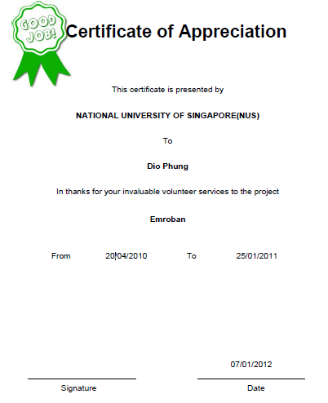

ANNEX A Amendment History

This is a record of all amendments made to the Document.
Version | Chapter / Section | Page No | Notes of Amendments or Changes

